2022 Tomato Plant Sale In conjunction with
1 plant/$1.00
5 plant/$3.00
10 plant/$5.00

NAME |  | FRUIT  SIZE | MATURE PLANT HEIGHT | HYBRID/ HEIRLOOM |  | USE
ДАМСКИЕ ПАЛЬЧИКИ  (LADY FINGERS) | Determinant | 2-3 oz. | 3 FT | HEIRLOOM |  | CONTAINER COMPATIBLE  canning Type  Usage Ladies' fingers are universal. prepare salads ketchup, tomato paste, preserve the fruits whole; dried, it turns out a real delicacy.
SILETZ | Determinant | 9-12 oz. | 2-3 feet | HYBRID | 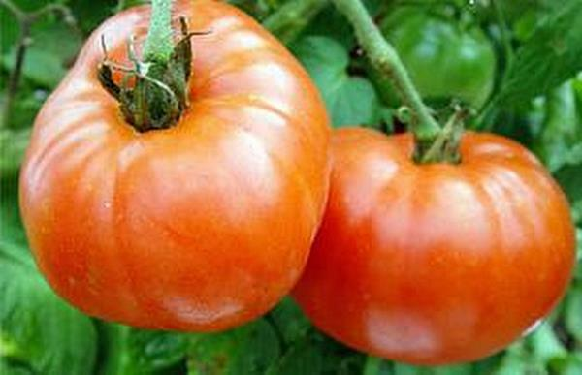 | CONTAINER COMPATIBLE  slicing type,  deep red, lavor packed, nearly seedless
BUSHSTEAK | Determinant | 8-12 oz. | 22 IN | HYBRID | 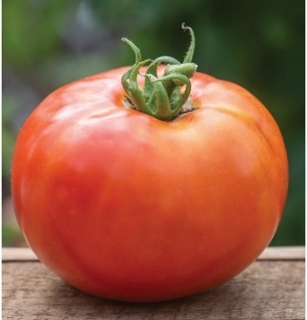 | CONTAINER COMPATIBLE  slicing type,  Well-suited for a patios, small gardens and containers, the dwarf plants offer big meaty fruit (8-12 oz.) and early maturity
ПЕРО ЖАР-ПТИЦІ  (FEATHER OF A FIRE-BIRD) | Semi-Determinate | 4-5 oz. | 20-30 in | HYBRID | 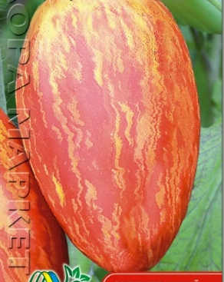 | The bush is medium-tall with a height The skin is dense and glossy. The flesh is dense. The taste is excellent, tomato with sweetness. Decorative salad and canned variety.
ACE 55 | Semi-Determinate | 10-ounce | 3-5 feet | HEIRLOOM | 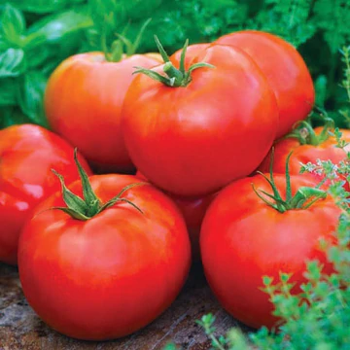 | Resistant to blossom end rot  superior drought resistance  low acidity Container Friendly
(ЧОРНИЙ КРИМУ)  BLACK KRIM  CRIMEA IS UKRAINE!! | Indeterminate | 8-16 oz. | 3-8 FT | HYBRID  Open pollinated | 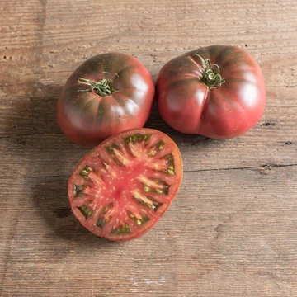 | resistance to disease and cracking sweet, slightly smoky, low acid, and rich in flavor
BRANDYWINE YELLOW | Indeterminate | 10-16 oz. | 5 ft | HEIRLOOM | 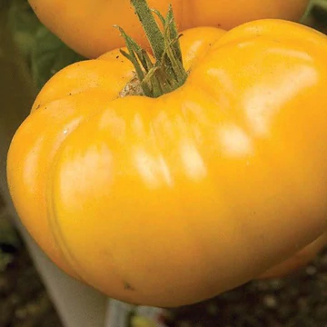 | Slicer  old-fashioned home-grown tomato taste .  low acidity yellow beefsteak
JUBILEE | Indeterminate | 8-16 oz | 4 ft | HEIRLOOM | 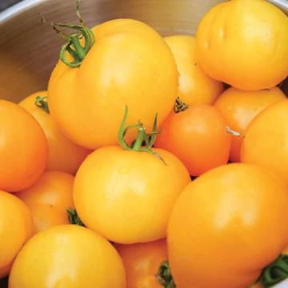 | SLICER  tolerant to drought, humidity, and heat sweet and low acidic qualitys
BIG BOY | Indeterminate | 10 - 16 OZ | 48 - 60 IN | Hybrid | 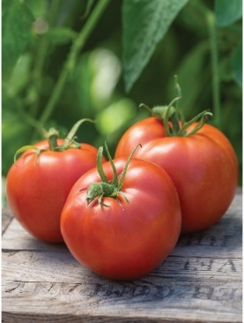 | incredible productivity and gorgeous, perfect, large red fruit
ЧОРНОБИЛЬ  CHERNOBYL | Indeterminate | 6-10 ounces | 4-5 feet tall | HEIRLOOM | 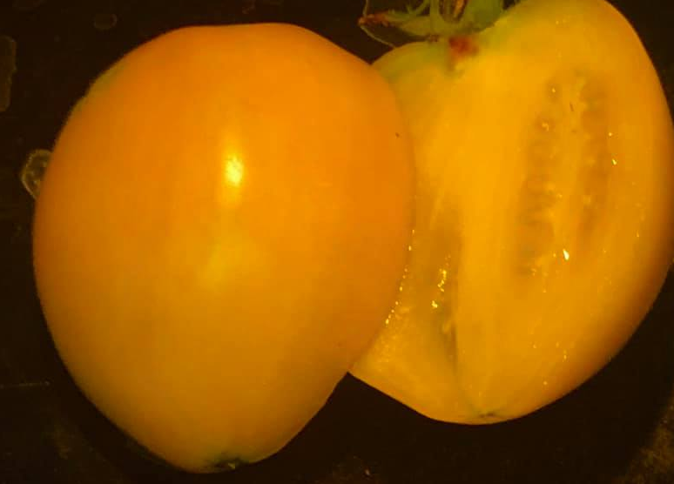 | perfect for canning and preserving  thick walls and tangy sweetness make the perfect addition to sauces, salsas and pastes
SWEET MILLION | Indeterminate | 1-2 inch | 5 ft | HYBRID | 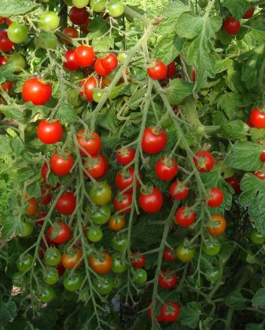 | Cherry type  can be enjoyed as an evening snack or in a salad.  crack-free and firm.
ДЯДЯ СТЕПА  (Uncle steppa) | Indeterminate | 3-6 oz. | 6 ft |  |  | Sweet and flavorful. Perfect for sauce, canning, and cooking  ideal in pickling, as they contain almost no juice, dense
BELARUSSIAN  HEART | Indeterminate | 6-16 oz. | 6-8 ft | Heirloom |  | They make great sauces also can be used in canning or slicing.

